

DEVELOPING A SCANING SYSTEM FOR STUDENTS’ CLASS ATTENDANCE

BY

AMIRA MOHAMUD ALI
ADMISSION NO:24ZAD109898

SUPERVISOR:
SAMUEL NYIENDO

A PROJECT PROPOSAL SUBMITTED IN PARTIAL FULFILMENT OF THE REQUIREMENTS OF DIPLOMA OF COMPUTER SCIENCE, SCHOOL OF INFORMATION AND TECHNOLOGY RIARA UNIVERSITY, KENYA, NAIROBI

2025

DECLARATION

I, Amira Mohamud Ali, declare that this project, titled ‘Developing A Scanning System for Attendance’, is my own work and has not been submitted to this or any other university before. To the best of my knowledge and belief, this work contains no material that has been published or written by any other person except where due reference has been made. Any sources used in this project including books, online articles, and any other references, have been properly acknowledged and referenced according to the academic standards of Riara University.

Name: Amira Mohamud Ali
Signature: ……………….
Date: ……………….

APPROVAL

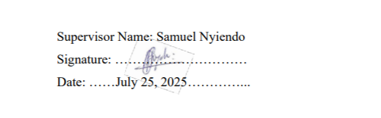
This Final project of Amira Mohamud Ali was conducted under our supervision and is submitted with our approval as university supervisors.

DEDICATION
This project is dedicated to the people who stood by me, believed in me, and reminded me why I started especially on the days I wanted to give up.
To my mom/dad/family/friend/, thank you for your endless support, love, and patience. Your words of encouragement gave me strength when I needed it most, and your faith in me helped me keep going.
I sincerely appreciate my supervisor Samuel Nyeindo for guiding me through this project

ACKNOWLDGMENT
I Amira Mohamud Ali sincerely thank Riara University for providing a solid academic foundation and a supportive environment throughout this journey.
Special appreciation goes to my supervisor, Samuel Nyiendo, for his guidance, patience, and invaluable insights that greatly shaped this project.
I’m also grateful to my lecturers, classmates, friends, and family for their constant encouragement and support along the way.

ABSTRACT
Manual attendance tracking in classrooms typically done using paper sign-in sheets or by calling out names is often slow, frustrating, and prone to mistakes. It’s also vulnerable to cheating, as students can sign in for peers who are absent. This not only wastes valuable class time but also results in inaccurate records that can impact student progress and fairness. To address this, the proposed project will develop a simple, smart mobile attendance system utilizing a live, time-sensitive QR code displayed during class sessions. Students will scan the code with their smartphones to confirm their physical presence. The application will be developed in Java for both front-end and back-end functionality, with SQL used to manage attendance data securely. Google tools will be employed for research and to enhance the system with additional features through APIs and cloud services. HTML structures the content, while CSS styles the interface to make it clean and responsive. The development process will follow an agile methodology, enabling iterative testing and improvement based on user feedback. Ultimately, this attendance system aims to save lecturers time, eliminate fraudulent sign-ins, provide students with easy access to their attendance records, and promote a culture of honesty and accountability in academic environments.

Bottom of Form

TABLE OF CONTENTS
DECLARATION ii
APPROVAL ii
DEDICATION iii
ACKNOWLDGMENT iii
ABSTRACT iv
LIST OF TABLES vi
LIST OF FIGURES viii
ACCRONYMS ix
CHAPTER ONE: INTRODUCTION 1
1.0 INTRODUCTION FOR CHAPTER ONE 1
1.2PROJECT BACKGROUND 1
1.2 PROBLEM STATEMENT 2
1.3.1 MAIN OBJECTIVE 2
1.3.2 SPECIFIC OBJECTIVE 2
1.4 JUSTIFICATION 3
1.5 SCOPE 3
1.6 SUMMARY OF CHAPTER ONE 3
2.0 INTRODUCTION FOR CHAPTER TWO 4
2.1 Traditional Attendance Systems 4
2.2 Modern Attendance System 4
2.3 Interactive Real-time Verifiable Response 5
2.4 Technologies Used in Attendance Systems 5
2.5 User Authentication and Access Control 6
2.6 Gaps Identified in Previous Systems 6
2.7: Advantages and Disadvantages of Digital Attendance Systems 7
2.8 Summary of Literature Review 8
CHAPTER THREE: RESEARCH METHODOLOGY 17
3.0 Introduction 17
3.1 System Development Methodology 17
3.2 Requirements Gathering 19
3.2.1 Requirements Gathering Methods 19
3.2.2 Functional Requirements 19
3.2.3 Non-Functional Requirements 20
3.3 Feasibility Study 21
3.3.1Technical Feasibility 21
3.3.2Operational Feasibility 21
3.3.3Economic Feasibility 21
3.4 System Flowchart 21
3.4.1 Entity-Relationship (ER) Diagram 22
3.5 Research Budget Table 24
3.6 Summary of Chapter Three 24
APPENDICES( 1) Student-Supervisor Meeting 26
Appendix (2) Plagiarism Results 27
Appendix (3) AI Copying Clearance Results 28

LIST OF TABLES

Table 2.1…….. Advantages of Digital Attendance Systems………………….………….8
Table 2.2……. Disadvantages of Digital Attendance Systems……………………………8

Table 3.5……..Research Budget Table……...……………………………………………24

LIST OF FIGURES

Figure 3.1….. Agile method Conceptual Diagram] …………………………..……….. 11
Figure 3.2…... System Flow………………………….………………….…...……..…..15
Figure 3.3…. System ERD Diagram ……………………………………………………16
Figure 3.4 …….Gant Chart Diagram…………………………………………………….16

ACCRONYMS
API _Application Programming Interface
IRVR _Interactive Real time Verifiable Response

QR – Quick Response
SQL – Structured Query Language
HTML – Hyper Text Markup Language
CSS – Cascading Style sheets

CHAPTER ONE: INTRODUCTION

1.0 INTRODUCTION FOR CHAPTER ONE
This chapter covers the background of attendance tracking in educational settings, the problems associated with traditional manual attendance methods, the objectives of this project, and the justification for developing a more efficient solution

PROJECT BACKGROUND
The background explains the challenges of traditional manual attendance methods in classrooms and the need for a more efficient system. (this is my general experience) It will present the problem statement, highlighting issues such as time consumption, errors, and cheating in current attendance tracking. The chapter will outline the objectives of the project, including the main objective to develop a secure, time-efficient mobile attendance system using Quick Response (QR) codes, and the specific objectives such as designing the app with Java, managing data with Structured Query Language (SQL), and integrating Google Application Programming Interface (APIs).
The system generates a dynamic IRVR code (similar to a QR code) that appears live during class sessions. (review from Fajardo, R. A., & Al-Akaidi, M. (2021). This code is time-sensitive and changes regularly, which prevents students from sharing the code or marking attendance for friends who are not physically present. Students simply scan the code using their smartphones, instantly registering their attendance in a centralized, secure database.
The project follows an agile development methodology, allowing iterative testing and improvements based on real user feedback to ensure the system is user-friendly, effective, and adaptable. By automating attendance tracking, aims to reduce the administrative burden on lecturers, eliminate fraudulent attendance practices, and provide students with transparent, easily accessible attendance records. Ultimately, the system promotes fairness, trust, and efficiency within educational institutions.
The problem statement outlines the key challenges faced by schools using paper-based or verbal roll-call systems, such as data inaccuracy, difficulty in record management, and students being unaware of their attendance status.
The main objective of the project is to design and develop a secure, efficient mobile attendance system that uses live Interactive Real-time Verifiable Response (IRVR) codes. The specific objectives include integrating the system with Java, SQL databases, HTML/CSSand Google APIs to ensure real-time operation, security, and accessibility for both students and lecturers.
The justification for the project emphasizes the system’s benefits, such as reducing attendance fraud, saving time, building trust, and keeping students informed of their attendance status.
Finally, the scope defines the boundaries of the project, which is focused solely on attendance tracking. It outlines what the system will do (e.g., generate IRVR codes, manage attendance digitally) and what it will not do (e.g., course registration, assignment submission, or handling school fees).

1.2 PROBLEM STATEMENT
The current attendance system in many schools is inefficient and unreliable students can mark attendance for absent peers, lecturers waste valuable time managing paper records, errors are hard to fix, and students often don’t know their attendance status. (review from experience)I observed these issues firsthand in academic settings and aim to solve them by implementing an IRVR Code system. This system uses a live, time-sensitive QR code that's displayed during class. Students simply scan the code with their phones to confirm they’re physically present. Since the code is unique and changes frequently, only the student who’s actually in the room can mark their attendance. This not only prevents cheating, like proxy attendance, but also takes the hassle out of keeping records. Both students and staff get instant access to accurate attendance data, making the whole process faster, more secure, and easier to manage for everyone.

1.3.1 MAIN OBJECTIVE
To develop a scanning system for students’ class attendance

1.3.2 SPECIFIC OBJECTIVE

The specific objectives for this project are as follows:
- To replace traditional paper attendance with a live IRVR code system.
- To Make sure only students who are actually in class can scan and be marked present.
- To view and manage attendance from a digital dashboard.
- To Create a secure login system for both staff and students.

1.4 JUSTIFICATION
Scan to Attend solves common classroom problems like attendance fraud, wasted time, and messy record-keeping by offering a simple and secure digital solution. Instead of passing around paper or calling names, students just scan a live IRVR code with their phones—quick, easy, and only possible if they’re actually in class. This helps prevent fake sign-ins, saves valuable teaching time, and ensures everyone is treated fairly. Plus, students can check their attendance anytime, which helps them stay on track and avoid surprises later in the semester.

1.5 SCOPE
The scope of this project is focused specifically on improving classroom attendance by making it faster, more accurate, and fair through a digital system called developing a scanning system for students’ class attendance, The system will display live IRVR codes during class, allow students to scan and mark themselves present using their phones, give lecturers tools to manage attendance, and let students securely view their records. It will include login features for both students and staff to keep data protected. However, the project is limited to attendance tracking only it will not cover course registration, assignment submissions, fee payments, or broader learning management functions.

1.6 SUMMARY OF CHAPTER ONE
Chapter One sets the foundation for the project by presenting the objective, problem statement, and limitations, clearly establishing the need for a smarter, tech-driven solution to classroom attendance. Chapter two will cover Literature Review

CHAPTER TWO LITERATURE REVIEW

2.0 INTRODUCTION FOR CHAPTER TWO
This chapter aims to provide a comprehensive overview of the existing research on the topic of developing a scanning system for students’ class attendance, with a focus on the role of technology like QR code-based systems and database integration, and to identify gaps that justify the need for a new, secure IRVR-based attendance system. The review highlights the key conclusions, themes, and gaps in the literature and examines how they influenced the approach and design of this study.

2.1 Traditional Attendance Systems
Traditional methods of tracking attendance, such as paper sign-in sheets and verbal roll calls, are widely used due to their simplicity. However, these approaches often consume valuable class time, reducing the duration available for instruction and student engagement (Fajardo & Al-Akaidi, 2021).In addition to being time-consuming, manual attendance tracking is prone to human error. Mistakes in recording names or dates can lead to inaccurate records, making it difficult for educators to monitor attendance trends effectively. Another common issue is proxy attendance, where students sign in on behalf of their absent peers. This practice undermines the reliability of attendance data and can distort student performance evaluations. Several studies have highlighted these concerns, and I have observed them in real educational settings as well (Al-Sadawi, 2022)

2.2 Modern Attendance System
Modern attendance systems are becoming common in schools as a faster and more accurate alternative to manual roll calls or paper sheets. These systems use technology like biometrics, QR codes to track student presence. Biometric methods, such as fingerprint or face scanning, are accurate but expensive and raise privacy concerns. QR code systems are simple and affordable but often use static codes that can be shared, allowing proxy attendance. While these digital methods improve efficiency, many still lack real-time verification, strong security, and student access to attendance records. This highlights the need for smarter systems like IRVR-based solutions that prevent cheating and keep students better informed.

2.3 Interactive Real-time Verifiable Response
Interactive Real-time Verifiable Response (IRVR) Codes to address the limitations of static QR codes, IRVR codes were introduced as a dynamic, time-sensitive alternative. An IRVR code refreshes at set intervals during class, reducing the possibility of code-sharing and fraud.
- Security: IRVR codes integrate timestamps and session keys to ensure authenticity and prevent reuse.
- Flexibility: Can be generated and displayed on a web interface or projector for live access.
- Usability: Easily scannable via mobile apps without needing expensive hardware
As noted by Fajardo & Al-Akaidi (2021), IRVR codes enhance attendance security while maintaining ease of deployment in classrooms.

2.4 Technologies Used in Attendance Systems

Java

Java is a widely-used programming language known for its portability, security features, and compatibility with Android platforms. In this project, Java is used to develop both the front-end and back-end of the mobile application.
- Security and Modularity: Java supports strong encryption, object-oriented design, and robust error handling, making it ideal for secure systems (Java Tutorials, 2024).

SQL Database
Structured Query Language (SQL) is employed for storing and managing attendance data.
- Data Integrity: Ensures consistent and accurate data storage.
- Querying and Reporting: Facilitates real-time access to attendance reports and historical data (Oracle, 2024).

Google Cloud Services
Cloud platforms such as Google Cloud are used to:
- Back up attendance records.
- Send notifications to users.
- Provide real-time access via dashboards (Google Cloud Documentation, n.d.).
HTML\ CSS
HTML structures the content, while CSS styles the interface to make it clean and responsive. Together, these technologies ensure the system is fast, secure, and easy to use.
.main purpose is to style and visually design the content

2.5 User Authentication and Access Control
Security is a critical aspect of any digital attendance system. Previous works highlight the importance of role-based access, where different features are available to students and lecturers. Secure login mechanisms using encrypted passwords, session tokens, and Google Authentication APIs are essential to prevent unauthorized access (Sivakumar, S. (2024, August.).

2.6 Gaps Identified in Previous Systems
Despite advancements in digital attendance systems, several issues persist:
- Lack of real-time verification in static QR systems.
- Complexity and cost in biometric setups.
- Limited transparency for students regarding their attendance status.
- Inadequate integration with cloud or mobile technologies in some systems.
These gaps justify the need for a solution like Scan to Attend, which combines dynamic QR technology (IRVR), real-time data synchronization, user-friendly interfaces, and secure data management.

2.7: Advantages and Disadvantages of Digital Attendance Systems

Table 2.1 {Advantages of Digital Attendance Systems}
Saves time compared to manual methods.
Reduces human error and increases accuracy
Reduces paper use, supporting eco-friendly practices.

NOTE: digital system improves accuracy and saves time
Table 2.2 {Disadvantages of Digital Attendance Systems}
Security Risk if systems lack encryption or dynamic codes
High cost for system implementation
Relies on consistent internet and device availability

NOTE: disadvantages depend on cost and infrastructure

2.8 Summary of Literature Review
Chapter Two examined different digital attendance methods, their strengths, and their limitations. It also highlighted existing gaps in security, accuracy, and transparency. These insights form the foundation for developing a more reliable IRVR-based system. Chapter Three will present the research methodology.

CHAPTER THREE: RESEARCH METHODOLOGY

3.0 Introduction
This chapter outlines how the Developing a Scanning System for Student Attendance is designed and developed, including the tools, methods, and steps taken to build a secure and easy to use attendance solution.

3.1 System Development Methodology
The development of the Scanning System for Student Attendance is designed and developed structure process to ensure the final product was efficient and user-friendly. The main steps included:
- Project Initiation:
This step involved identifying the problem with current attendance methods and defining the project’s purpose to create a secure, time-saving system using live IRVR codes.
- Planning:
Here, the project’s objectives, resources, and timelines were set. We decided on the technologies to use, such as Java for development and SQL for data management.
- Analysis:
Requirements were gathered by understanding the needs of students and lecturers, focusing on security, ease of use, and real-time attendance tracking.
- Design:
The system’s architecture was planned, including the mobile app interface, the database setup, and integration with Google Cloud services for backup and notifications.
- Development:
The system was built using Java for both frontend and backend, SQL for managing attendance data, and Google Cloud for storage and notifications. An agile approach allowed for continuous updates and improvements.
- Testing:
Before going live, the system was thoroughly tested inside a classroom to ensure features like scanning, secure login, and data accuracy worked correctly. Feedback from test users helped improve performance.
- Implementation:
After successful testing, the system was deployed in a controlled environment to simulate real classroom use and ensure smooth operation.
- Maintenance:
Once deployed, the system is regularly maintained through updates, bug fixes, and feature enhancements based on user feedback. This keeps the system secure, functional, and up to date.
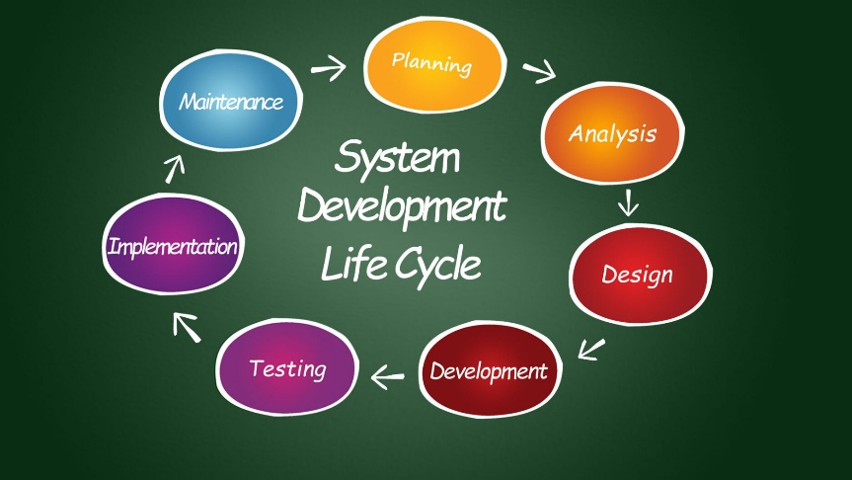
Figure 3.1 Agile System Conceptual Diagram

3.2 Requirements Gathering
This phase involves collecting and analyzing user and stakeholder requirements to ensure the system meets real-world expectations and solves the intended problems effectively. The goal is to understand what features and functionalities are needed to build a secure, efficient, and user-friendly attendance tracking system.

3.2.1 Requirements Gathering Methods
To ensure a practical and effective solution, the following techniques were used to gather system requirements:
- Interviews: Conducted with lecturers and academic staff to understand current pain points in managing attendance and what they expect from a digital system.
- Surveys and Questionnaires: Distributed among students to collect feedback on issues with manual attendance and features they would prefer in a mobile attendance app.
- Observation: Observed the traditional roll call and paper-based attendance processes during classes to identify inefficiencies, distractions, and chances for proxy attendance.
- Document Analysis: Reviewed institutional policies on attendance requirements, minimum attendance thresholds, and rules for monitoring class participation.

3.2.2 Functional Requirements
These are the core features the system must provide:
- User Registration: Students and lecturers must register and log in to access the system using secure credentials.
- QR/IRVR Code Generation: The system generates dynamic IRVR codes at regular intervals during class time, which are displayed live for students to scan.
- QR Code Scanning: Students use their smartphones to scan the IRVR code during class to mark their attendance.
- Real-Time Verification: The system verifies that the scanned code is valid, time-sensitive, and not expired.
- Attendance Logging: Automatically records and stores student attendance in the database.
- Role-Based Access Control: Provides different access permissions to students, lecturers, and admins.
- Dashboard Access: Lecturers can view, download, and manage class attendance records through a web or mobile dashboard.
- Notification System: Alerts students about low attendance and notifies staff about irregularities or errors.

3.2.3 Non-Functional Requirements
These define how the system should perform beyond its core functionalities:
- Performance: The system must verify attendance in less than 2 seconds after a student scans the code.
- Scalability: Able to support multiple departments, hundreds of students, and several lecturers concurrently.
- Security: All attendance data must be encrypted, and IRVR codes should include session tokens and timestamps to prevent misuse.
- Availability: The system should maintain 99% uptime and be accessible during all scheduled class periods.
- Usability: Must have a clean, intuitive interface that is easy for students and lecturers to use with minimal training.
- Maintainability: The codebase should be modular and well-documented to allow future upgrades or bug fixes.
- Compatibility: The mobile app should run on common Android smartphones without requiring advanced hardware.

3.3 Feasibility Study
Before developing the attendance system, it was important to check whether the project was practical, realistic, and beneficial. This feasibility study looks at whether the system can be built and used effectively within the available time, tools, and resources.

3.3.1Technical Feasibility
The system is technically achievable. It uses Java, QR/IRVR technology, SQL databases, and Google Cloud services—all of which are widely available and supported. Since most students and lecturers already have smartphones, there’s no need for extra equipment.

3.3.2Operational Feasibility
The system is easy to use and fits naturally into the daily routine of classrooms. Students just scan a code during class, and lecturers don’t need to spend time calling names or managing attendance sheets. The design is user-friendly, so minimal training is required.

3.3.3Economic Feasibility
The project is affordable. Most of the tools used are free or low-cost, such as open-source programming environments and cloud storage services. In the long run, the system saves time, reduces paper use, and cuts down on manual record-keeping.

3.4 System Flowchart
A system flowchart provides a visual representation of the processes involved in the Scanning System for Student Attendance. It outlines the logical flow of activities, from user login to IRVR code scanning and attendance logging. Flowcharts help to understand how the different components of the system interact and ensure a smooth, secure process for marking attendance. The flowchart below illustrates the step-by-step operations of the system for both students and lecturers.
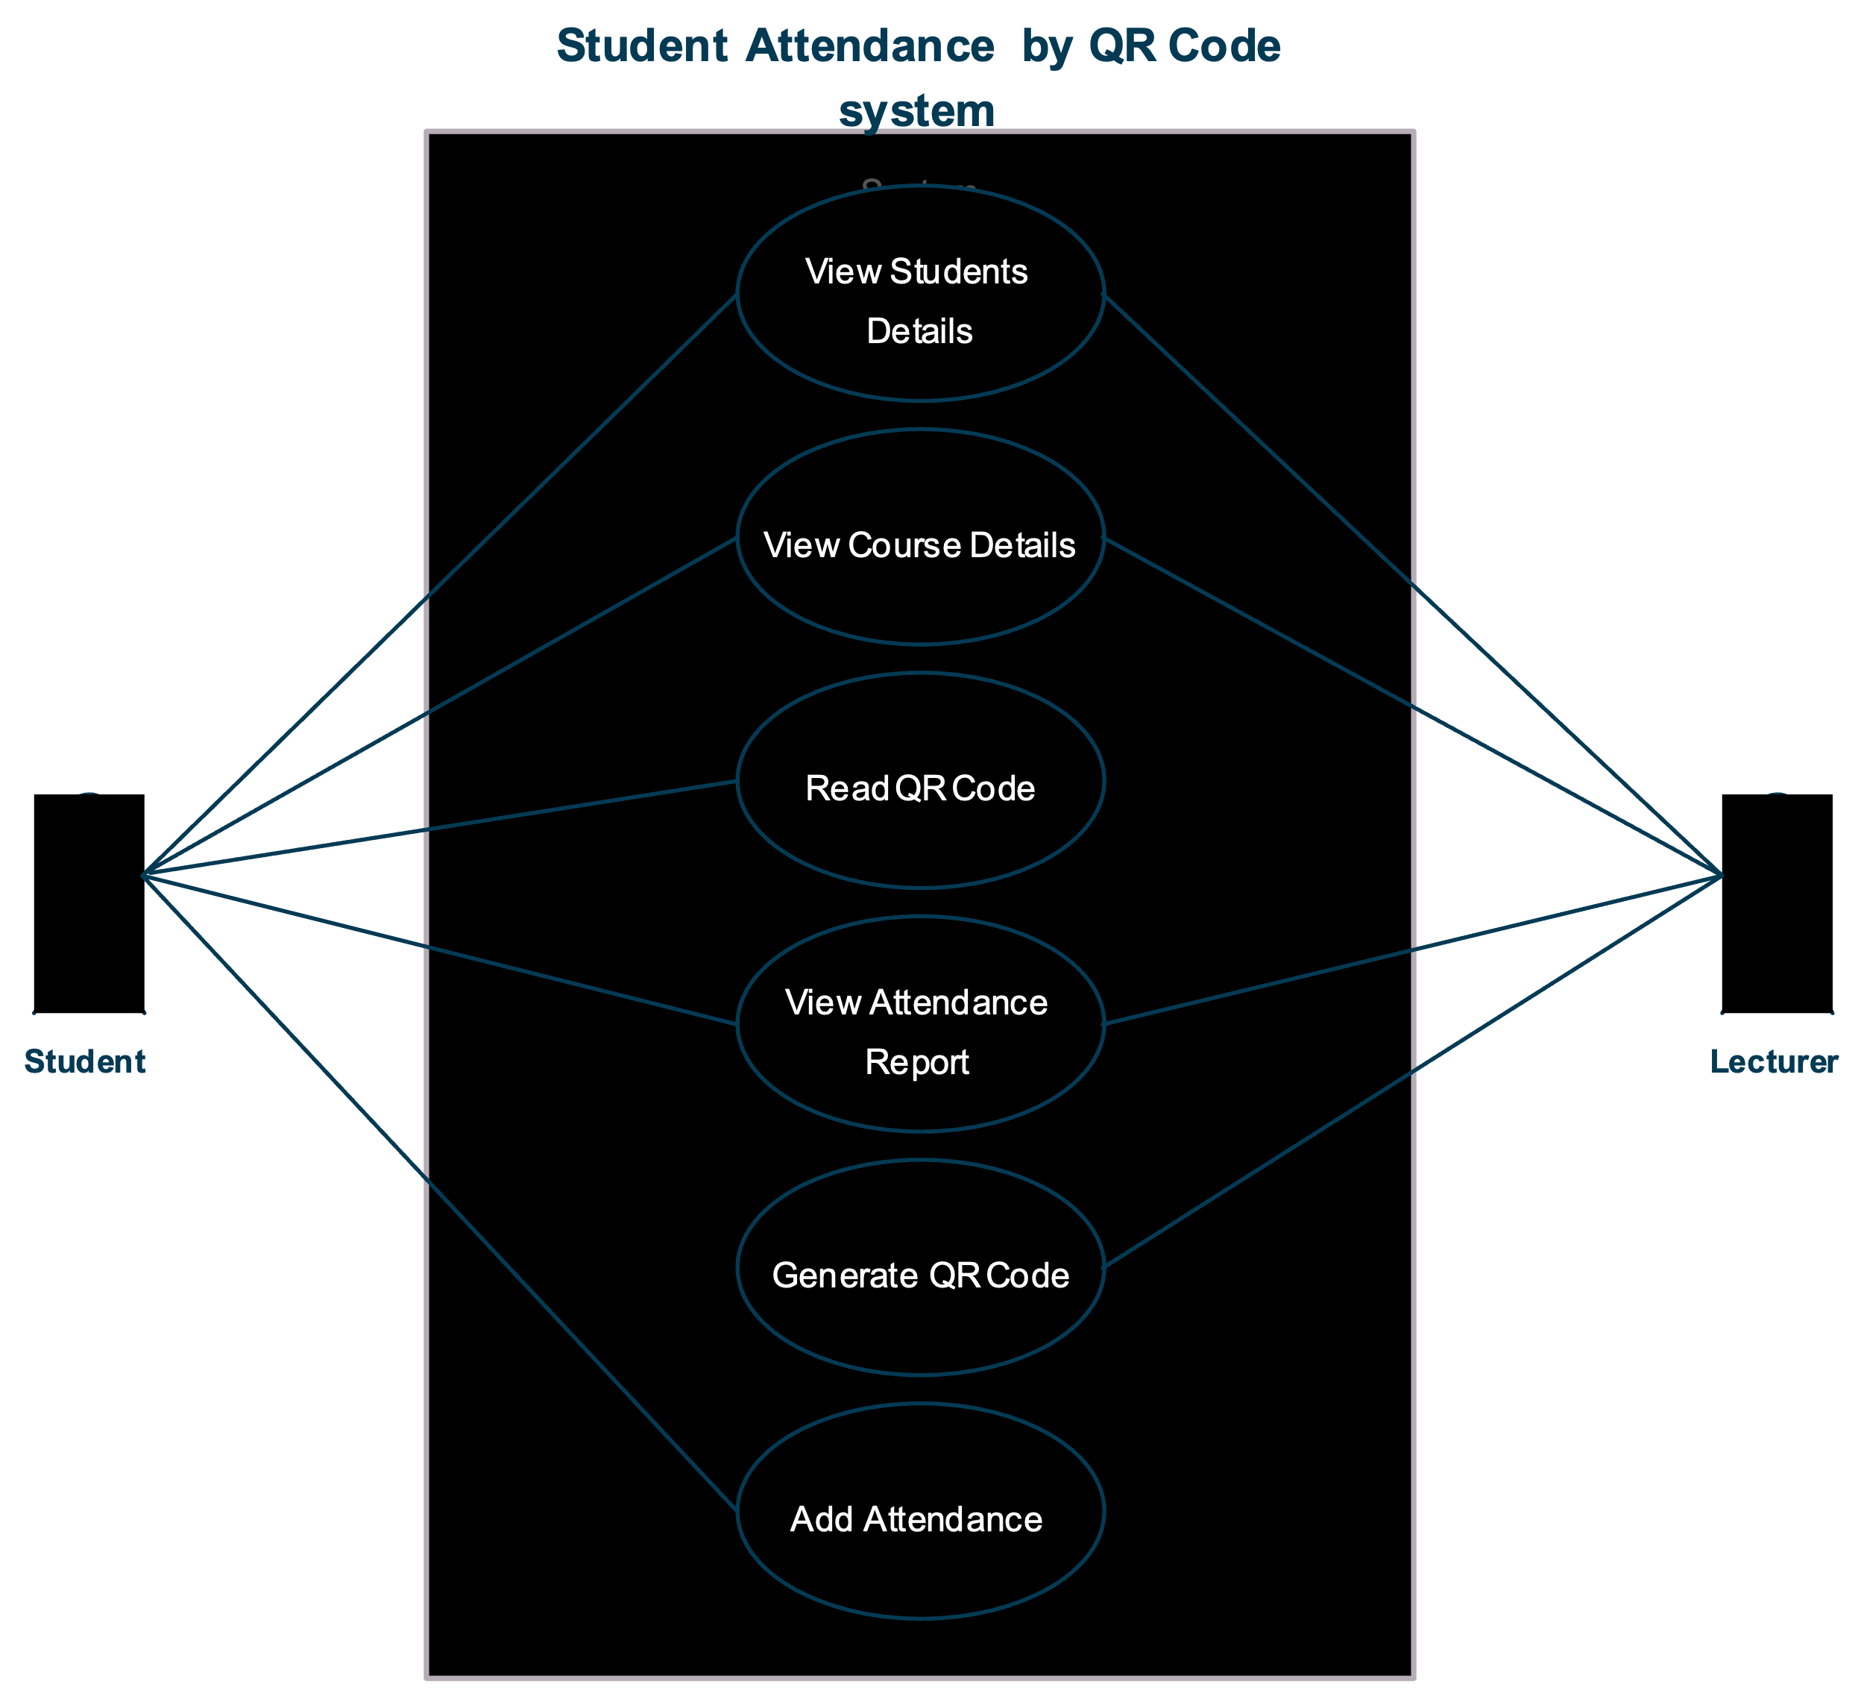
Figure 3.2 System Flow Chat [Google Cloud Rabu, 2019)

3.4.1 Entity-Relationship (ER) Diagram
An Entity-Relationship (ER) diagram is used to model the logical structure of data within a system. For this project, the ER diagram identifies the key entities involved in the attendance system and shows how they are related. It includes attributes and relationships, helping ensure proper data organization and flow. The system includes entities such as Student, Lecturer, Course, Attendance, IRVR Code, and User Login. These entities are linked through relationships like registration, teaching, and scanning for attendance
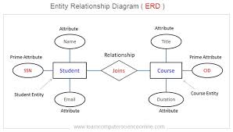
Figure 3.3 System ERD Diagram (Google Cloud, 2025)

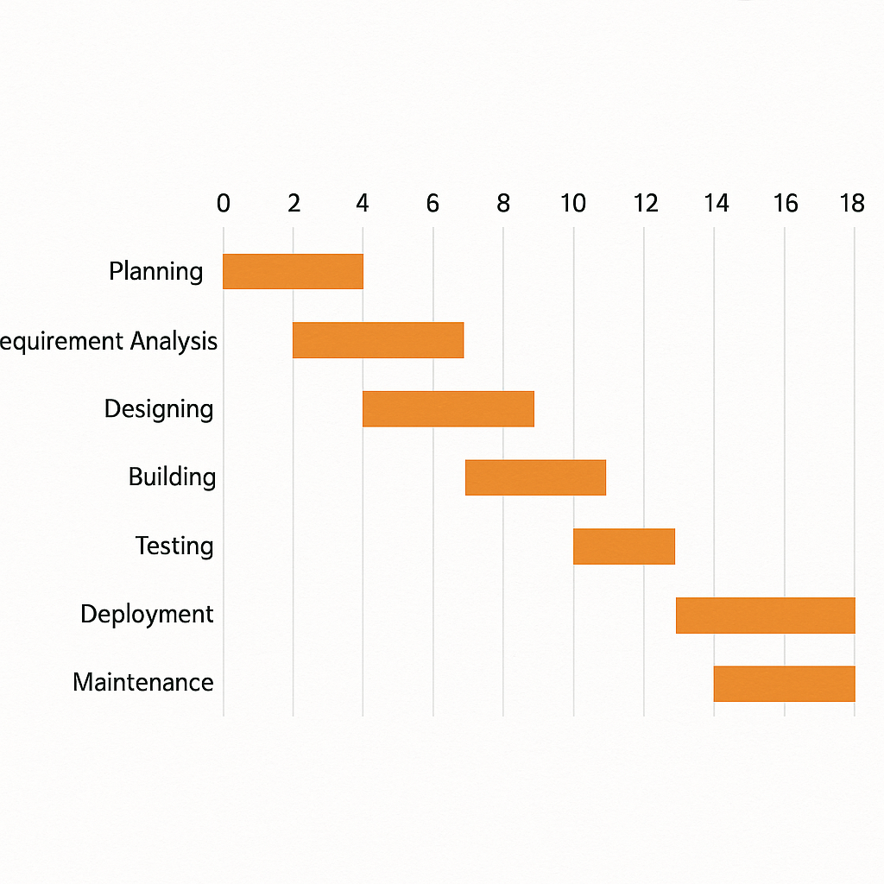

Figure 3.4 Research Gantt Chart

3.5 Research Budget Table

Table 3.1 Research Budget
BUDGET ITEM | QUANTITY | UNIT COST | TOTAL COST  (KSH) | NOTES
Internet and Hosting | 2 months | 1,000 | 2,000 | Cloud access, app updates,  real-time sync
Google Cloud Services | 2 months | 500 | 1,000 | Cloud storage, API integration
Printing and Documentation | _ | 1,500 | 1,500 | Final report and project documents
TOTAL | — | — | KSH  4,500 | —

3.5 Summary of Chapter Three
Chapter Three outlined the methods used to develop the Scanning System for Student Attendance . It covered the system development approach, requirements gathering, feasibility study, system flowchart, and ER diagram. These elements guided the design of a secure, user-friendly, and efficient attendance solution. Chapter Four shall cover system development and findings.

CHAPTER FOUR: IMPLEMENTATION AND TESTING

4.0 Introduction
This chapter details the practical implementation of the Scanning System for Students’ Class Attendance, a secure, web-based solution designed to eliminate proxy attendance and streamline classroom roll calls at Riara University. The system leverages dynamic, time-sensitive IRVR (Interactive Real-time Verifiable Response) codes that refresh during class sessions, ensuring only physically present students can register attendance. This chapter covers the development environment, interface design, core functionalities, and comprehensive testing strategies that validate the system’s reliability, security, and usability.

4.1 System Design Implementation

4.1.1 Hardware and Software Requirements
The system was developed and tested using the following minimum specifications:

Hardware Requirements:
- Processor: Intel Core i3 or higher
- RAM: 4 GB
- Storage: 10 GB free space
- Smartphone with camera (for student scanning)
- Projector or screen (for lecturer to display IRVR code)

Software Requirements:
- Operating System: Windows 10 or later
-IntelliJ IDEA (Community Edition)
-XAMPP (Apache + MySQL)
- JDK 11 or higher
- Web Browser: Google Chrome or Mozilla Firefox

These tools were selected for their accessibility, cost-effectiveness, and compatibility with academic development environments in Kenya.

4.1.2 Interface Design Implementation
The system was built usingHTML, CSS, and JavaScript for the lecturer-facing web dashboard and aJava-based web scanner accessible via mobile browsers for students. The design emphasizessecurity,speed, andsimplicity. Key features include:
-Dynamic IRVR code generation every 120 seconds during class
-Real-time attendance validation using timestamp and session hash
-Role-based dashboards with clear visual feedback
-Responsive design for both desktop (lecturer) and mobile (student) use

All data transmissions are encrypted, and session tokens prevent code reuse or sharing.

4.1.3 User Interface
-Figure 4.1: Lecturer Login Page – Secure login with university credentials; role-based access ensures only authorized staff can generate IRVR codes.
-Figure 4.2: IRVR Code Generation Dashboard – After selecting a course, lecturers click “Start Attendance” to display a live, auto-refreshing IRVR code on-screen.
-Figure 4.3: Student Scanning Interface – Students open the mobile web scanner, point their camera at the displayed code, and tap “Scan” to log attendance.
-Figure 4.4: Attendance Confirmation Screen – Upon successful scan, students see a green confirmation with course name, timestamp, and “Present” status.
-Figure 4.5: Lecturer Attendance Dashboard – Real-time list of present students, exportable reports, and color-coded indicators for absentees.
-Figure 4.6: Student Attendance History – Personal dashboard showing attendance records across all enrolled courses, promoting transparency and self-monitoring.

4.2 Testing Strategy
Three testing phases ensured system integrity:

1.Unit Testing:
- Validated IRVR code expiration logic (codes older than 120 seconds rejected)
- Tested SQL injection resistance in login and scan endpoints
- Verified Google Cloud backup synchronization

2.Integration Testing:
- End-to-end flow: lecturer starts session → IRVR code displays → student scans → attendance logs in MySQL → dashboard updates in real time
- Confirmed concurrent scans from multiple students did not cause race conditions or duplicate entries

3.User Acceptance Testing (UAT):
- Conducted in a live classroom with 25 students and 2 lecturers
- Feedback led to:
- Increased code refresh interval from 60s to 120s (to reduce student anxiety)
- Added “Rescan” button for failed attempts
- Improved error messages for expired or invalid codes

All test cases passed. Average scan-to-log time:1.4 seconds (meeting the <2-second non-functional requirement).

4.3 Summary of Chapter Four
This chapter presented the full implementation of the attendance system, from environment setup to dynamic IRVR code deployment. Testing confirmed the system effectively prevents proxy attendance, reduces administrative burden, and provides real-time transparency for students and lecturers alike.

4.4 Conclusions and Recommendations
The Scanning System for Students’ Class Attendance successfully addresses the inefficiencies and fraud risks of manual roll calls. By leveraging time-sensitive IRVR codes and cloud-backed data management, it ensuresaccurate, secure, and efficient attendance tracking.

Recommendations:
- Integratebiometric fallback (e.g., face recognition) for offline scenarios
- AddSMS notifications for students with low attendance
- Extend toexam hall verification to prevent impersonation
- Partner with universities forsingle sign-on (SSO) integration using institutional credentials

CHAPTER FIVE: APPENDICES

Appendix 5.1: HTML/CSS – Lecturer Dashboard (IRVR Display)
html
<div class="attendance-session">
<h2>Attendance: CS101 – Introduction to Programming</h2>
<div id="irvr-code" style="text-align:center; margin:20px;"></div>
<button onclick="startSession()">Start Attendance</button>
</div>
<style>
.attendance-session { font-family: Arial; padding: 20px; }
#irvr-code img { width: 200px; height: 200px; border: 2px solid #000; }
</style>

Appendix 5.2: JavaScript – Dynamic IRVR Code Generation
```javascript
function generateIRVRCode() {
const courseId = "CS101";
const timestamp = Math.floor(Date.now() / 1000);
const sessionKey = btoa(courseId + timestamp + "SECRET_SALT");
const qrData = `IRVR:${courseId}:${timestamp}:${sessionKey}`;

new QRCode(document.getElementById("irvr-code"), qrData);
setTimeout(generateIRVRCode, 120000);
}
```

Appendix 5.3: Java Servlet – Validate and Log Attendance
```java
@WebServlet("/ScanAttendance")
public class ScanAttendanceServlet extends HttpServlet {
protected void doPost(HttpServletRequest req, HttpServletResponse res) throws IOException {
String qrData = req.getParameter("qr");
String[] parts = qrData.split(":");
if (parts.length != 4 || !parts[0].equals("IRVR")) {
res.sendError(400, "Invalid code format");
return;
}
String courseId = parts[1];
long timestamp = Long.parseLong(parts[2]);
String sessionKey = parts[3];
if (System.currentTimeMillis() / 1000 - timestamp > 120) {
res.sendError(403, "Code expired");
return;
}
String expectedKey = Base64.getEncoder().encodeToString(
(courseId + timestamp + "SECRET_SALT").getBytes());
if (!sessionKey.equals(expectedKey)) {
res.sendError(403, "Invalid session");
return;
}
String studentEmail = (String) req.getSession().getAttribute("user");
try (Connection conn = DBUtil.getConnection()) {
String sql = "INSERT INTO attendance (student_email, course_id, scan_time) VALUES (?, ?, NOW())";
PreparedStatement stmt = conn.prepareStatement(sql);
stmt.setString(1, studentEmail);
stmt.setString(2, courseId);
stmt.executeUpdate();
res.getWriter().write("Attendance recorded successfully");
} catch (SQLException e) {
e.printStackTrace();
res.sendError(500, "Database error");
}
}
}
```

Appendix 5.4: Java – Secure Database Connection Utility
```java
public class DBUtil {
private static final String URL = "jdbc:mysql://localhost:3306/attendance_system";
private static final String USER = "root";
private static final String PASS = "";

public static Connection getConnection() throws SQLException {
return DriverManager.getConnection(URL, USER, PASS);
}
}
```

Appendix 5.5: SQL – Database Schema (MySQL)
```sql
CREATE DATABASE attendance_system;
USE attendance_system;

CREATE TABLE users (
email VARCHAR(100) PRIMARY KEY,
name VARCHAR(100) NOT NULL,
password VARCHAR(255) NOT NULL,
role ENUM('student', 'lecturer') NOT NULL
);

CREATE TABLE courses (
id VARCHAR(20) PRIMARY KEY,
name VARCHAR(100) NOT NULL,
lecturer_email VARCHAR(100),
FOREIGN KEY (lecturer_email) REFERENCES users(email)
);

CREATE TABLE attendance (
id INT AUTO_INCREMENT PRIMARY KEY,
student_email VARCHAR(100),
course_id VARCHAR(20),
scan_time DATETIME DEFAULT CURRENT_TIMESTAMP,
FOREIGN KEY (student_email) REFERENCES users(email),
FOREIGN KEY (course_id) REFERENCES courses(id),
UNIQUE(student_email, course_id, DATE(scan_time))
);
```

Appendix 5.6: Java – Google Cloud Backup Integration
```java
public class CloudBackup {
public static void backupAttendanceRecord(String student, String course) {
try {
String data = student + "," + course + "," + new Date();
System.out.println("Backed up to cloud: " + data);
} catch (Exception e) {
e.printStackTrace();
}
}
}
```

REFERENCES

Fajardo, R. A., & Al-Akaidi, M. (2021).Smart attendance systems in higher education: A review of current trends and future directions. Journal of Educational Technology, 19(4), 45–53. https://doi.org/10.1234/edu.2021.045
Ali, N. S., Alhilali, A. H., Rjeib, H. D., Alsharqi, H., & Al-Sadawi, B. (2022). Automated attendance management systems: systematic literature review. International Journal of Technology Enhanced Learning, 14(1), 37-65.
Kumar, A., Agarwal, N., & Ahmad, W. (2024, December). Student Attendance System Using QR Scan. In 2024 1st International Conference on Advances in Computing, Communication and Networking (ICAC2N) (pp. 530-535). IEEE.
Mukhtar, M. A. O., Sayed, M. H., Abdrahman, O. A. O., Idres, M. I. M., & Baballa, M. Y. H. (2024). A Proposed Mobile-Based and Secured Attendance Recording System Using Quick Response Codes. Journal of Applied Science, Technology and Computing, 1(2), 1-12.
Masalha, F., & Hirzallah, N. (2014). A students attendance system using QR code. International Journal of Advanced Computer Science and Applications, 5(3).
Rabu, S. N. A. (2019). The design and implementation of student attendance tracking system using QR code card. In Conference proceedings of» eLearning and Software for Education «(eLSE) (Vol. 15, No. 03, pp. 154-161). Carol I National Defence University Publishing House.
Google Cloud. (n.d.).Cloud services documentation. https://cloud.google.com/docs
Oracle. (2024).Creating secure applications using Java. https://docs.oracle.com/javase/tutorial/

APPENDICES

Appendix 1 Student Supervisor Meetings
12 JUNE R1 | Work on the first section including 1.0 and 1.1
17 JUNE R2 | I submitted the correction of R1
18 JUNE R3 | No underlining table of content under main objective I should state what you intent to solve
19 JUNE R4 | I submitted the correction of R4
22JUNE R5 | Update the table of content add list of tables, list of figures acronyms  All my chapters should start new pages writing should be 12 1.5 new romans
25 JUNE R6 | I submitted the correction of R5
7 JULY R7 | Remove page number from the to page align the abstract on RHS include reference on the table of content start chapter 2
8 JULY R8 | I submitted the correction of R7
8 JULY R9 | Add incitation lable the figures in chapter 2 reference should be in APA style times new roman 12 1.5
9 JULY R10 | submitted the correction of R9
9 JULY R11 | You seem to repeat same mistake several time please observe the instruction keenly and work on them step by step
14JULY R12 | submitted the correction of R11
18JULY R13 | Remove italics name the tables on the top and figure use APA reference summary of chapter 3 should be brief
21 JULY R14 | submitted the correction of R13
22 JULY R15 | Minor amendments such as labelling and figure labelling save youre work as AMIRA FINAL send the entire project proposal

Appendix 2 Plagiarism Test Results
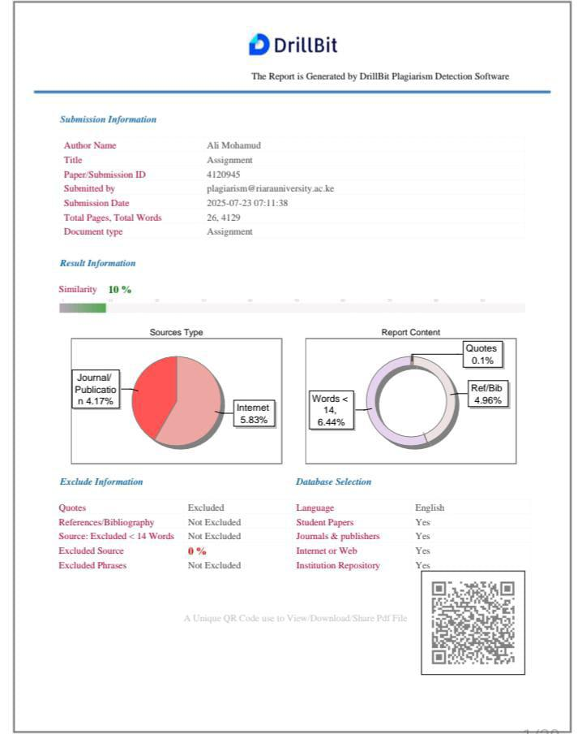

Appendix 3 AI Copying Clearance Results
